**Lab Report #2:** LEDs, Square Wave, Button, Pins

Brian Dawson

Joshua Annandsingh

Microcomputer Systems

8/30/19

The College of New Jersey

Department of Electrical and Computer Engineering (ECE)



**Introduction:**

In this lab the students had to develop a basic PSoC creator program using the CY8CKIT-050 kit. The first part was to generate a square wave at one of the output pins of the chip and then light up a LED. The second part was to use push buttons to also light up a LED while also having the square wave running.

**Procedure:**

Part 1:

1. The students created a new PSoC project.
2. The students then added a digital output pin to the main PSoC schematic and then unchecked the “HW connection” as shown in Figure one.
3. The students then created the main.c file and wrote the code to produce a square on the output pin at the maximum frequency.
4. The students downloaded the program to the board and then connected the board to the oscilloscope to ensure the program was working correctly as shown in Figure two, three, and four.

Part 2:

1. The students then wired one of the LED’s that aren’t connected to any MCU pins to the output pin previously created.
2. The first program was then changed using the CyDelay() program so that the first LED would cycle ON-OFF once per second.
3. The students then added a second digital output pin and a digital input pin to the schematic as shown in Figure one. They also made sure to make the input pin’s drive state to resistive pull up.
4. Then students selected one of the push buttons on the board and then mapped it to the digital input pin.
5. The students then added code to main.c that read the state of the pushbutton and if it was pressed the LED would turn on and vice versa. This was code so that it would happen while the other LED flashed.
6. The students then downloaded the program to the board and confirmed that it functioned correctly as shown in Figure five and six.

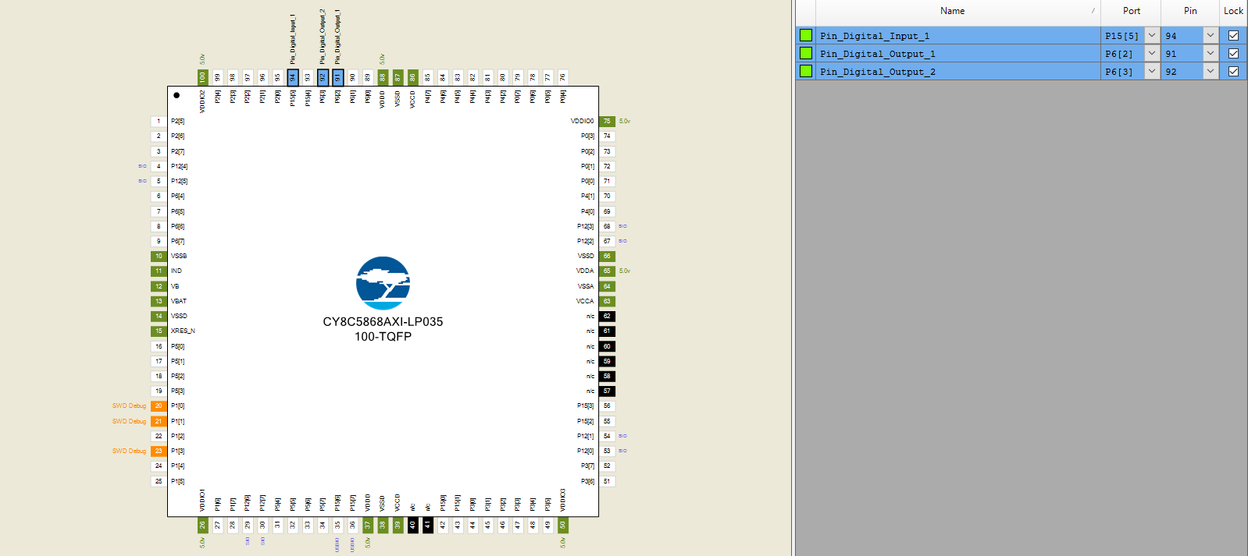

*Figure 1. PSoC Creator Schematic*

**Results:**

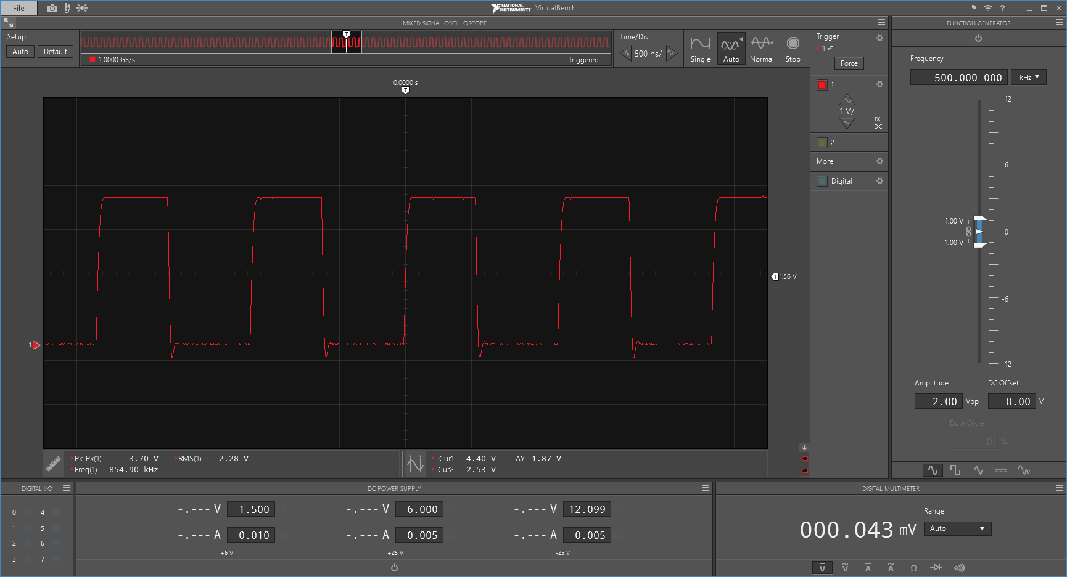

*Figure 2. Oscilloscope Reading for square wave at maximum frequency*

|  |  |
| --- | --- |
| Time/Division | 500 ns |
| Volts/Division | 1V |
| Frequency | 854.90 kHz |

*Table 1. Values of Oscilloscope reading*

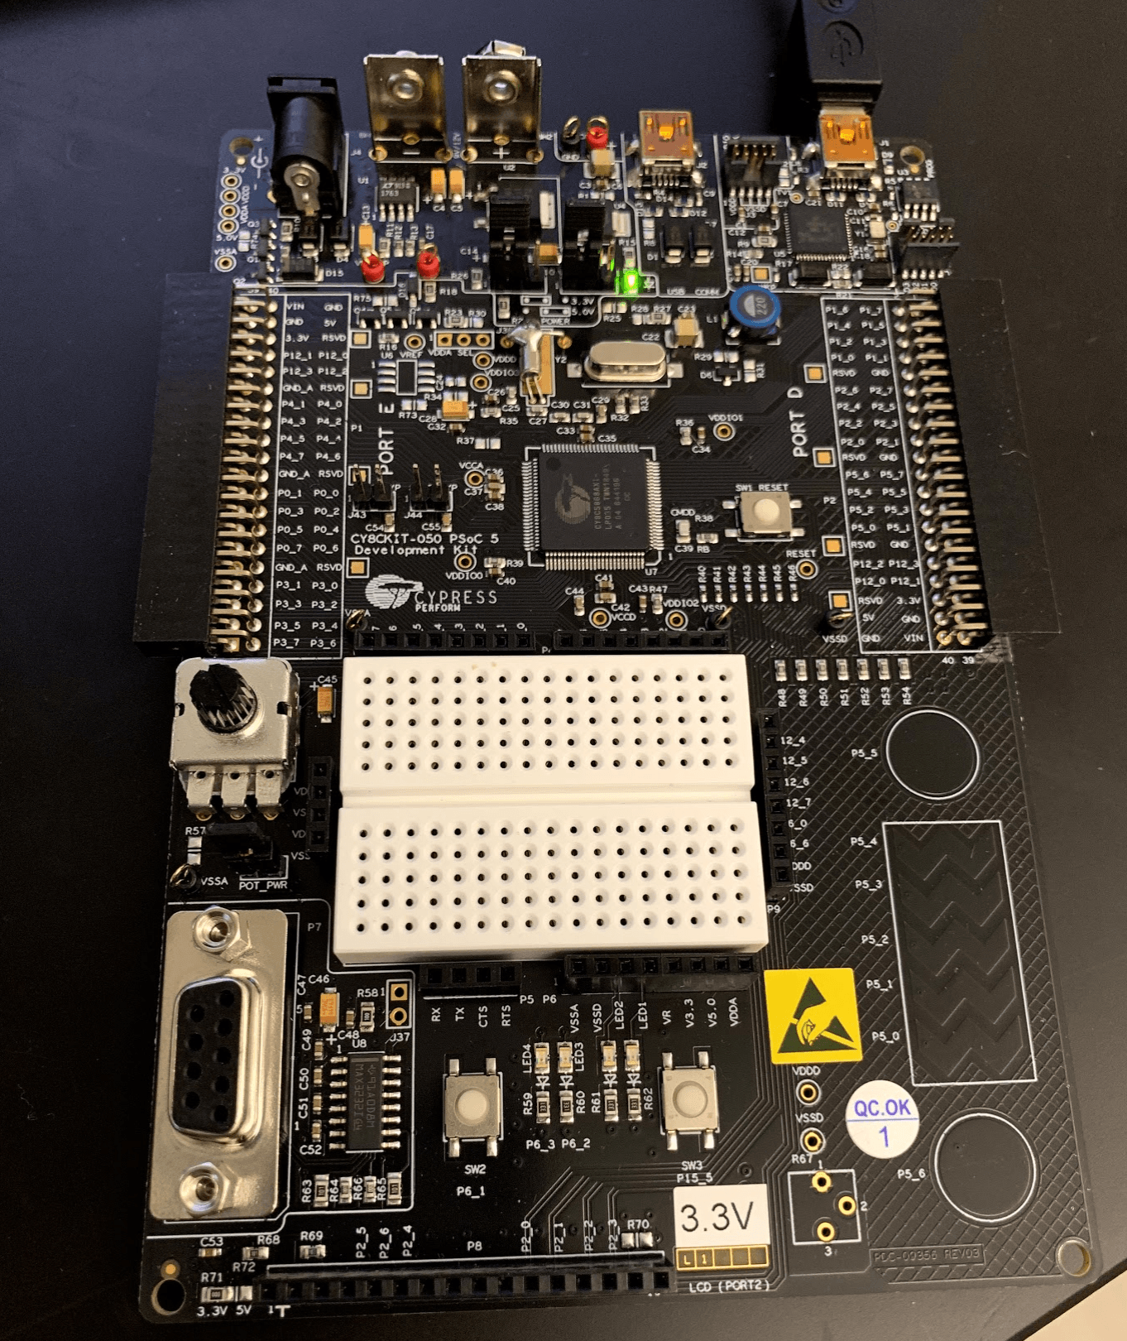

*Figure 3: Part 1 Circuit with LED off*

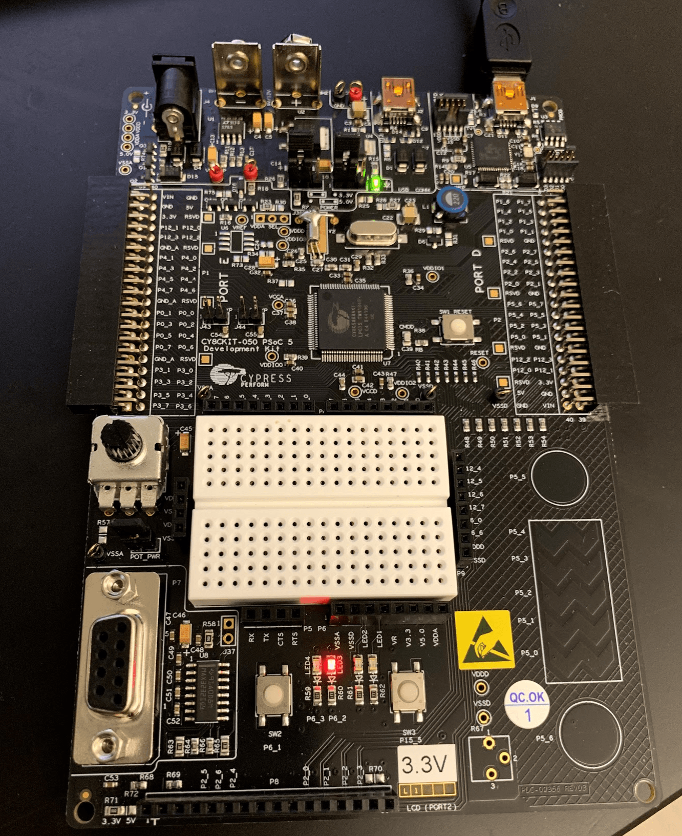

*Figure 4: Part 1 Circuit with LED on*

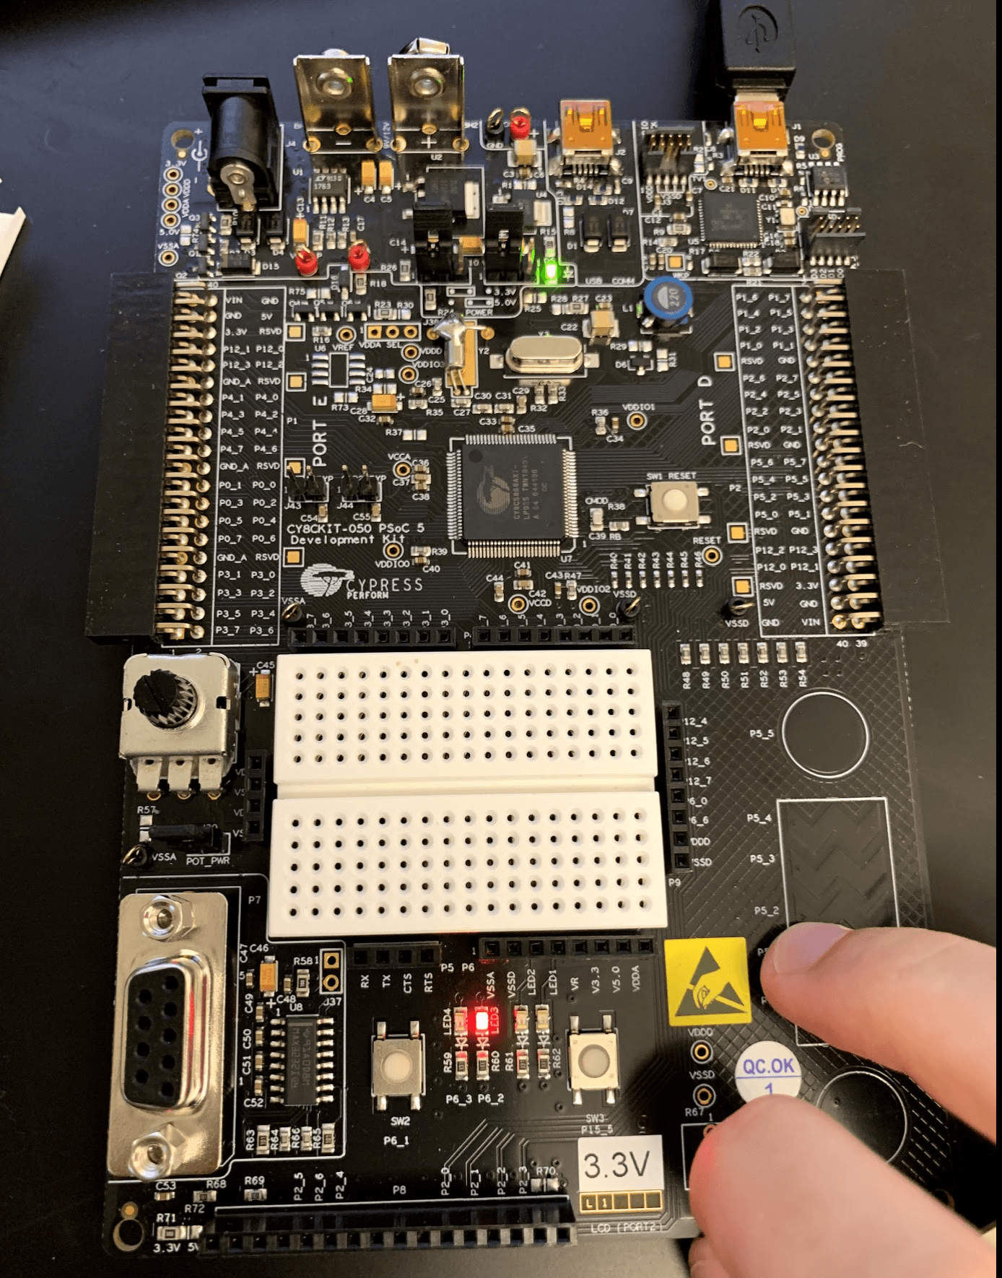

*Figure 5: Part 2 Circuit with push button LED not on*

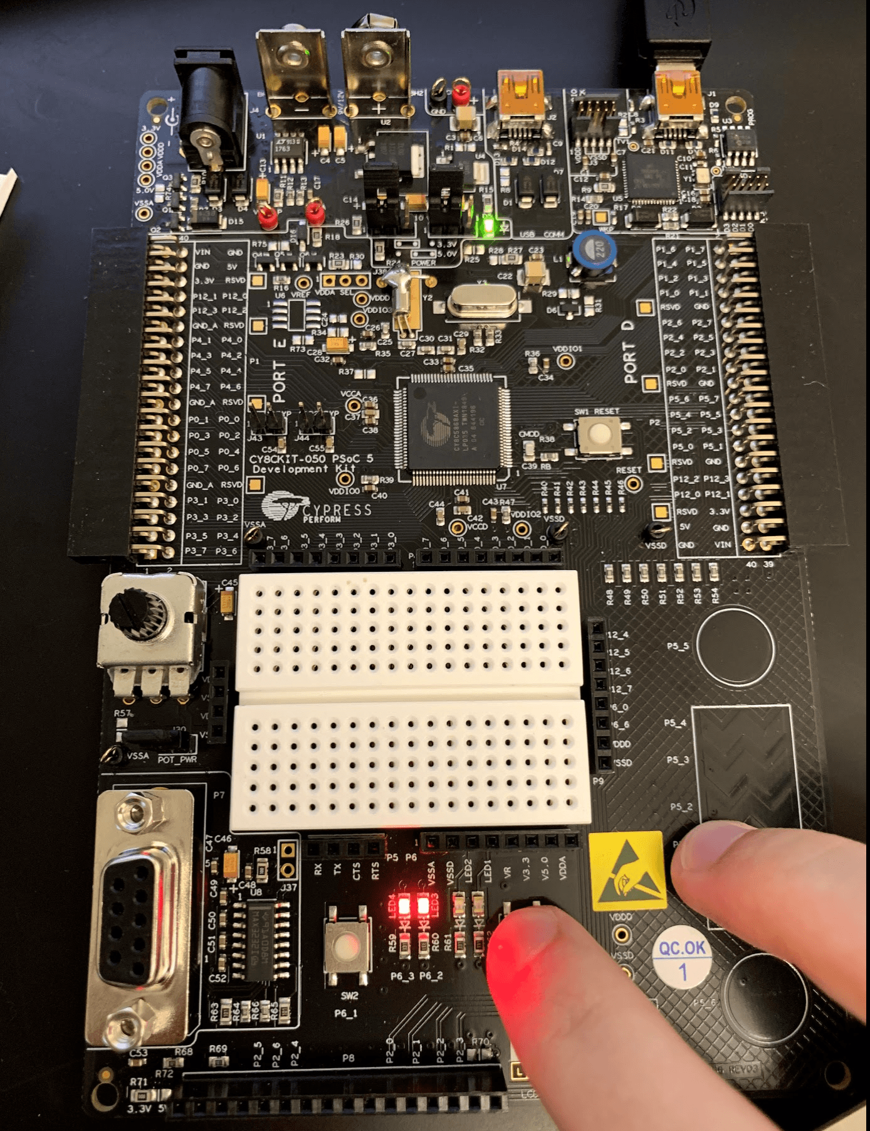

*Figure 6: Part 2 Circuit with push button LED on*

**Discussion:**

Both Part 1 and Part 2 worked without any issues and the students were able to achieve the desired results using the code generated and the board used. It was interesting how high the frequency got when the square wave was generated with no delay.

**Code:**

#include "project.h"

#define on 1u

#define off 0u

int main(void)

{

CyGlobalIntEnable; /* Enable global interrupts. */

for(;;)

{

Pin_Digital_Output_1_Write(on);

Pin_Digital_Input_1_Read() == on ? Pin_Digital_Output_2_Write(off) : Pin_Digital_Output_2_Write(on);

CyDelay(500);

Pin_Digital_Output_1_Write(off);

Pin_Digital_Input_1_Read() == on ? Pin_Digital_Output_2_Write(off) : Pin_Digital_Output_2_Write(on);

CyDelay(500);

Pin_Digital_Input_1_Read() == on ? Pin_Digital_Output_2_Write(off) : Pin_Digital_Output_2_Write(on);

}

}